**Turdalin Nurassyl LAB2**

**3.7.10**

**Part 1**

IP of my PC : 192.168.0.113(Основной)

IP of my phone : 192.168.0.190

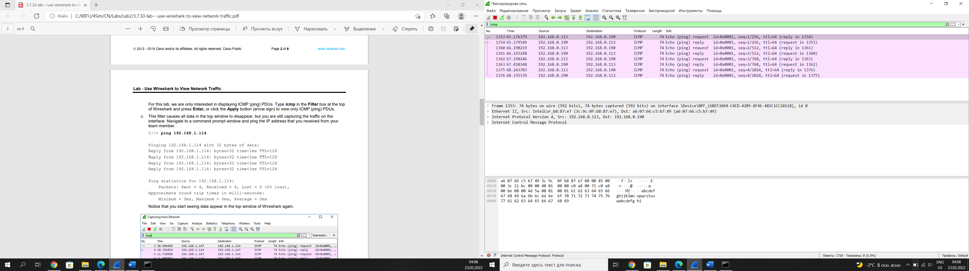 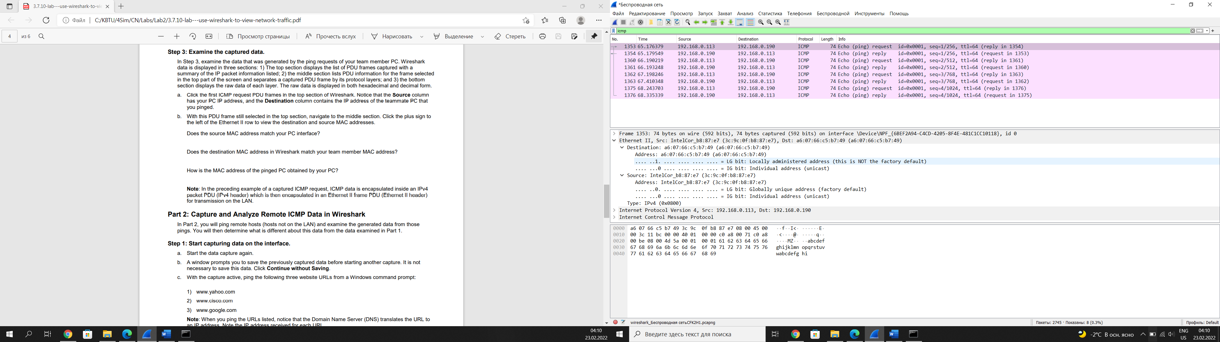

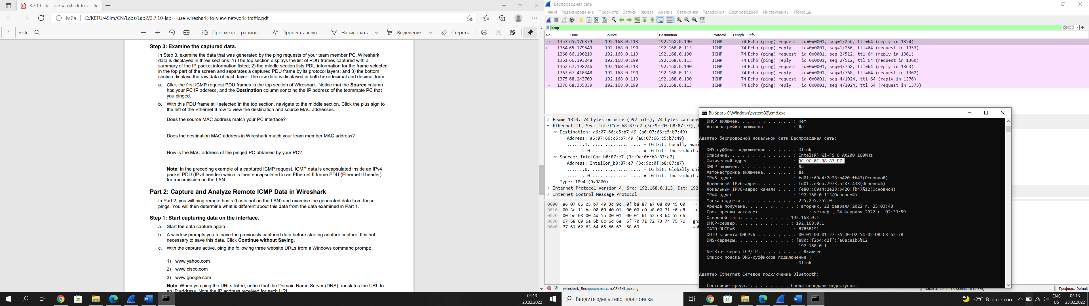

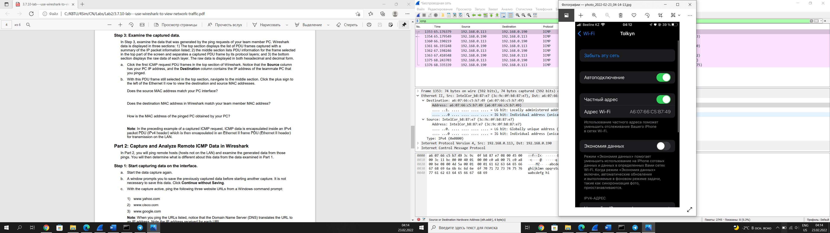

**Part 2**

IP address for www.yahoo.com: Source Address: 87.248.100.215

MAC address for [www.yahoo.com](http://www.yahoo.com): Address: D-LinkIn_6e:e1:b5 (f0:b4:d2:6e:e1:b5)

IP address for [www.cisco.com](http://www.cisco.com): Source Address: 23.43.131.231

MAC address for [www.cisco.com](http://www.cisco.com): Address: D-LinkIn_6e:e1:b5 (f0:b4:d2:6e:e1:b5)

IP address for [www.google.com](http://www.google.com): Source Address: 216.58.210.164

MAC address for www.google.com: Address: D-LinkIn_6e:e1:b5 (f0:b4:d2:6e:e1:b5)

They have same MAC addresses. It’s the physical address of the default-gateway LAN interface of the router. Then it will go further to reach server.

A ping to a local host returns the MAC address of the PC NIC. A ping to a remote host returns the MAC address of the default gateway LAN interface.

MAC addresses for remote hosts are not known on the local network, so the MAC address of the default-gateway is used. After the packet reaches the default-gateway router, the Layer 2 information is stripped from the packet and a new Layer 2 header is attached with the destination MAC address of the next hop router.